Assignment No. 06
- TITLE : Implementation of Inheritance for Employee Payroll System in C++.
- Problem Statement :
Design and develop an inheritance-based system where:
- The Employee class contains data members: Emp_name, Emp_id, Address, Mail_id, and Mobile_no.
- The classes Programmer, Team Lead, Assistant Project Manager, and Project Manager are inherited from Employee.
- Each class includes Basic Pay (BP) as a member.
- Calculate allowances and deductions:
  - DA = 52% of BP
  - HRA = 27% of BP
  - PF = 12% of BP
  - Staff Club Fund = 0.1% of BP
- Generate a pay slip with Gross Salary and Net Salary.

- Salary Computation –
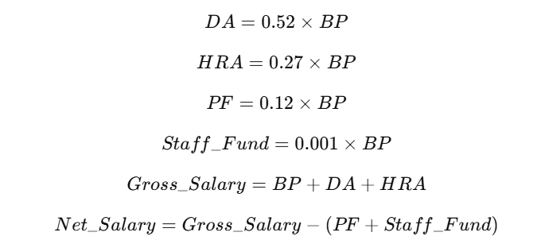
- Algorithm –

- Start.
- Define base class Employee with attributes: Emp_name, Emp_id, Address, Mail_id, Mobile_no.
- Derive classes Programmer, TeamLead, AsstProjectManager, ProjectManager from Employee.
- Add data member BasicPay and functions for salary calculation in derived classes.
- Input employee details and BP.
- Compute DA, HRA, PF, Staff Club Fund, Gross Salary, and Net Salary.
- Display a pay slip with all details.
- End.

- Code –
#include <iostream>
#include <string>
using namespace std;

class Employee {
public:
int emp_id;
string emp_name, emp_addr, emp_mail;
long long emp_phone;

void getDetails() {
cin.ignore();
cout << "Enter Employee Name: ";
getline(cin, emp_name);
cout << "Enter Employee ID: ";
cin >> emp_id;
cin.ignore();
cout << "Enter Address: ";
getline(cin, emp_addr);
cout << "Enter Mail ID: ";
getline(cin, emp_mail);
cout << "Enter Mobile Number: ";
cin >> emp_phone;
}

void displayDetails() {
cout << "\nEmployee Details:\n";
cout << "Name: " << emp_name << endl;
cout << "ID: " << emp_id << endl;
cout << "Address: " << emp_addr << endl;
cout << "Mail ID: " << emp_mail << endl;
cout << "Mobile Number: " << emp_phone << endl;
}
};

class Salary : public Employee {
public:
float BasicPay, DA, HRA, PF, StaffClubFund, GrossSalary, NetSalary;

virtual void getSalary() {
cout << "Enter Basic Pay Salary: ";
cin >> BasicPay;
}

virtual void calculate() {
DA = 0.52 * BasicPay;
HRA = 0.27 * BasicPay;
PF = 0.12 * BasicPay;
StaffClubFund = 0.001 * BasicPay;
GrossSalary = BasicPay + DA + HRA;
NetSalary = GrossSalary - (PF + StaffClubFund);
}

virtual void generatePaySlip() {
displayDetails();
cout << "Basic Pay: " << BasicPay << endl;
cout << "DA: " << DA << endl;
cout << "HRA: " << HRA << endl;
cout << "PF: " << PF << endl;
cout << "Staff Club Fund: " << StaffClubFund << endl;
cout << "Gross Salary: " << GrossSalary << endl;
cout << "Net Salary: " << NetSalary << endl;
}
};

class Programmer : public Salary {
public:
void calculate() override {
DA = 0.40 * BasicPay;
HRA = 0.20 * BasicPay;
PF = 0.10 * BasicPay;
StaffClubFund = 0.001 * BasicPay;
GrossSalary = BasicPay + DA + HRA;
NetSalary = GrossSalary - (PF + StaffClubFund);
}
void generatePaySlip() override {
cout << "\nPay Slip: Programmer\n";
Salary::generatePaySlip();
}
};

class TeamLead : public Salary {
public:
void calculate() override {
DA = 0.45 * BasicPay;
HRA = 0.22 * BasicPay;
PF = 0.11 * BasicPay;
StaffClubFund = 0.001 * BasicPay;
GrossSalary = BasicPay + DA + HRA;
NetSalary = GrossSalary - (PF + StaffClubFund);
}
void generatePaySlip() override {
cout << "\nPay Slip: Team Lead\n";
Salary::generatePaySlip();
}
};

class AsstProjectManager : public Salary {
public:
void generatePaySlip() override {
cout << "\nPay Slip: Assistant Project Manager\n";
Salary::generatePaySlip();
}
};

class ProjectManager : public Salary {
public:
void calculate() override {
DA = 0.55 * BasicPay;
HRA = 0.30 * BasicPay;
PF = 0.12 * BasicPay;
StaffClubFund = 0.001 * BasicPay;
GrossSalary = BasicPay + DA + HRA;
NetSalary = GrossSalary - (PF + StaffClubFund);
}
void generatePaySlip() override {
cout << "\nPay Slip: Project Manager\n";
Salary::generatePaySlip();
}
};

int main() {
int choice;
cout << "Select Employee Type: \n1. Programmer\n2. Team Lead\n3. Assistant Project Manager\n4. Project Manager\n";
cin >> choice;

Salary* emp = nullptr;

switch (choice) {
case 1: emp = new Programmer(); break;
case 2: emp = new TeamLead(); break;
case 3: emp = new AsstProjectManager(); break;
case 4: emp = new ProjectManager(); break;
default: cout << "Invalid choice!" << endl; return 0;
}

emp->getDetails();

emp->getSalary();
emp->calculate();
emp->generatePaySlip();

delete emp;
return 0;
}
- Output –
Select Employee Type:
1. Programmer
2. Team Lead
3. Assistant Project Manager
4. Project Manager
3
Enter Employee Name: Apurv
Enter Employee ID: 123
Enter Address: Pune
Enter Mail ID: apurv@gmail.com
Enter Mobile Number: 7058229202
Enter Basic Pay Salary: 75000
Pay Slip: Assistant Project Manager

Employee Details:
Name: Apurv
ID: 123
Address: Pune
Mail ID: apurv@gmail.com
Mobile Number: 7058229202
Basic Pay: 75000
Conclusion –
In this assignment, we implemented inheritance and calculated the salary components on an employee salary payroll management system.
DA: 39000
HRA: 20250
PF: 9000
Staff Club Fund: 75
Gross Salary: 134250
Net Salary: 125175

